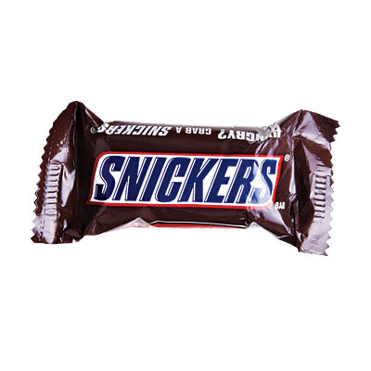
B’s Weekly Assignments
NAME: | Mr Burrill | MONTH: | December | YEAR: | 2020

  MON: | [12/2]
  TUES: | [12/3]
  WED: | [12/4]
  THUR: | [12/5]
  FRI: | [12/6]

Odd | Even | odd | even | odd
[Algebra II]
 | Page 41- Even |  | Page 47- Odd
[Chemestry]
Read Chapter 16 |  | Lab- Calcium |  | Read Chapter 17
[Sign Language]
 | Skit Performance |  | Workbook- Ch 7

[American Lit]
Reading Quiz |  | Journal |  | Journal
Vocabulary Quiz

[US History]
 | Presentation- Lincoln |  | Grade Presentations

[Baseball]
Practice | Practice | Practice | Practice | Practice
Odd | Even | odd | even | odd
I LOVE HOMEWORK

